SD.1-1: Administrator add a product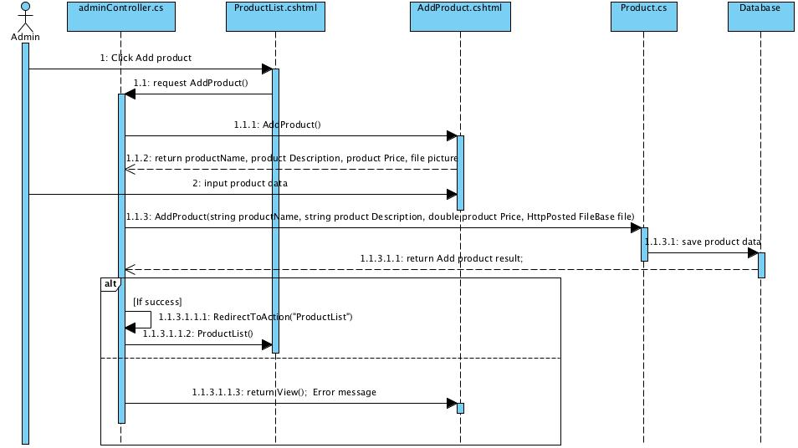

SD.1-2: User login as Administrator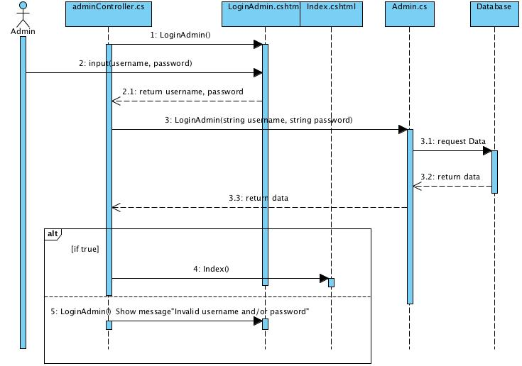

SD.1-3: Administrator edit the Payment Information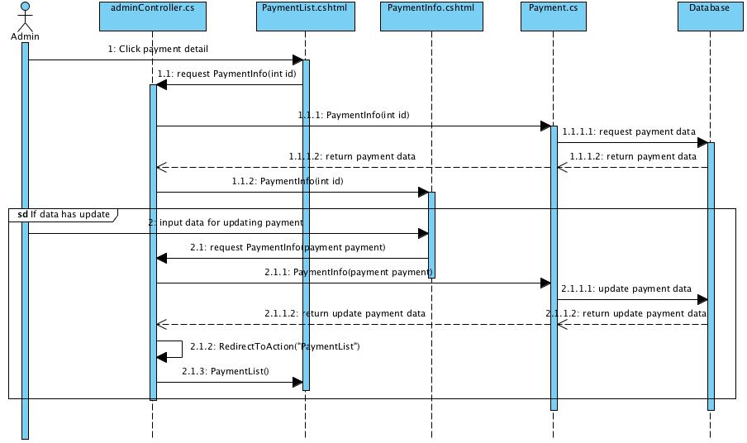

SD.1-4: Administrator view Payment List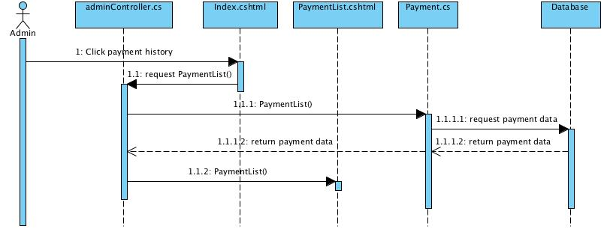

SD.1-5: Administrator edit the Product Information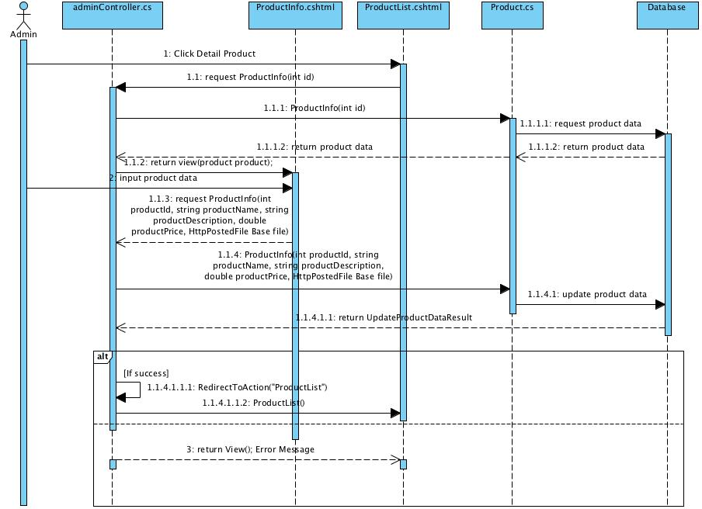

SD.1-6: Administrator view Product List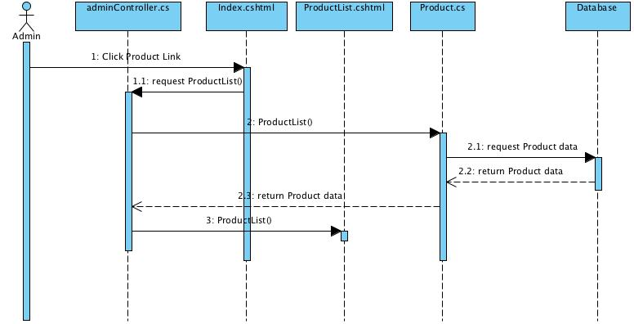

SD.1-7: Administrator view Shopping Cart item(s)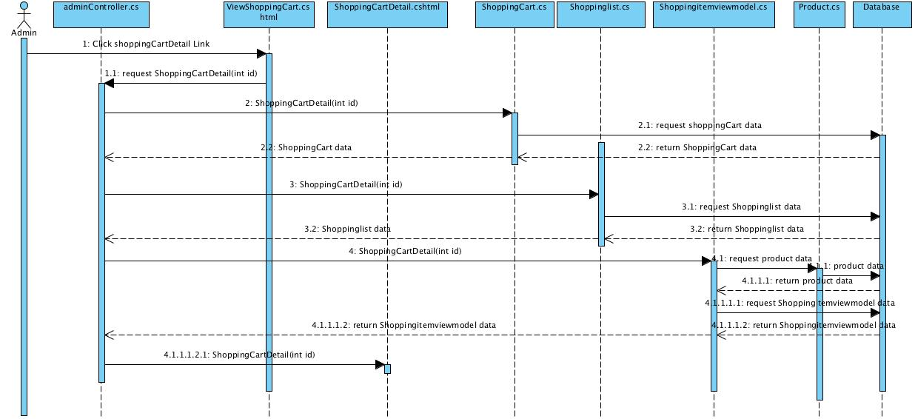

SD.2-1: Customer check out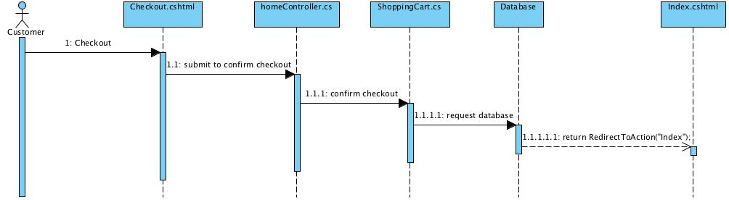

SD.2-2: Customer edit his/her own information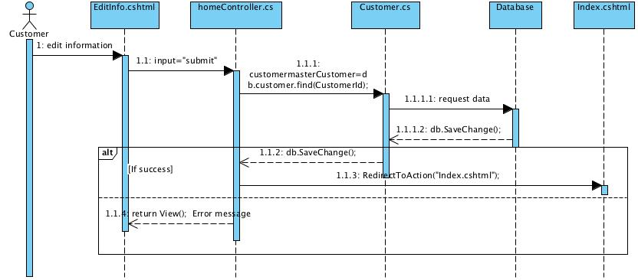

SD.2-3: User login as Customer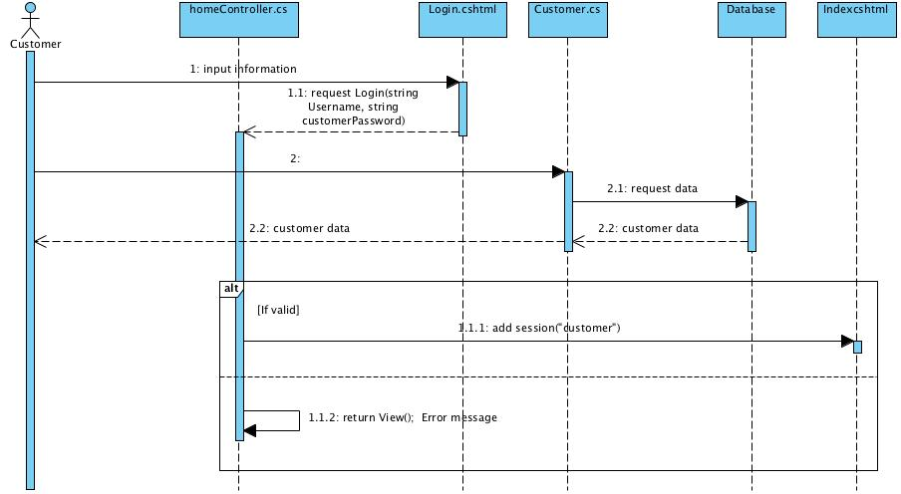

SD.2-4: Customer view Payment History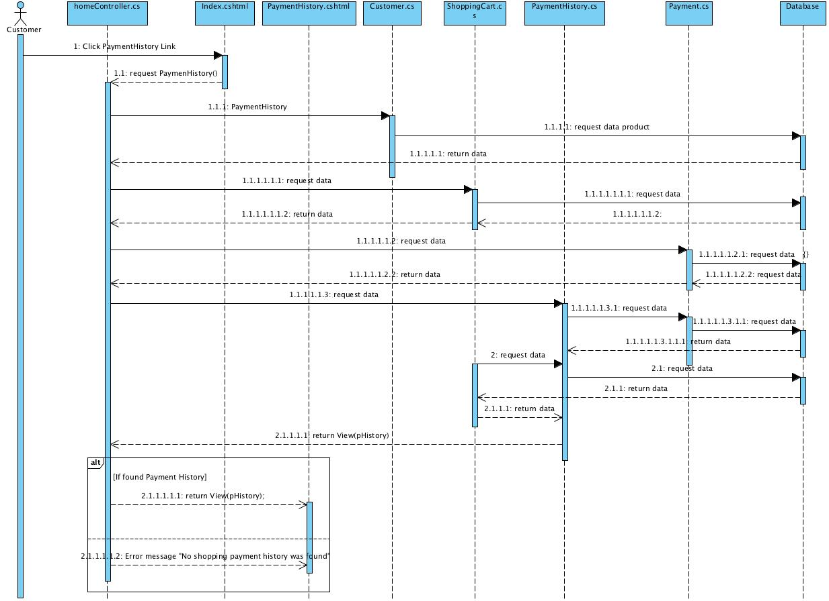

SD.2-5: User register as Customer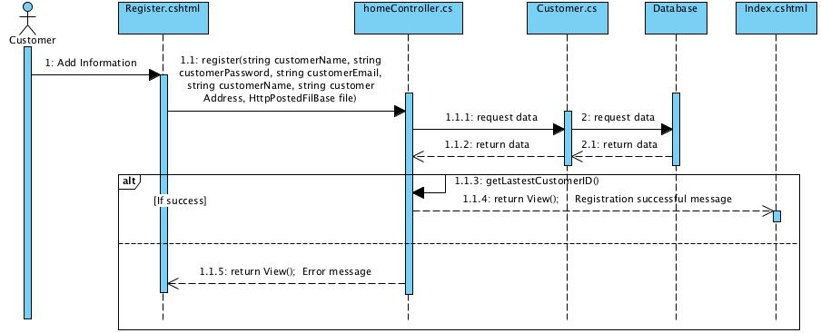

SD.2-6: Customer search for the products by keywords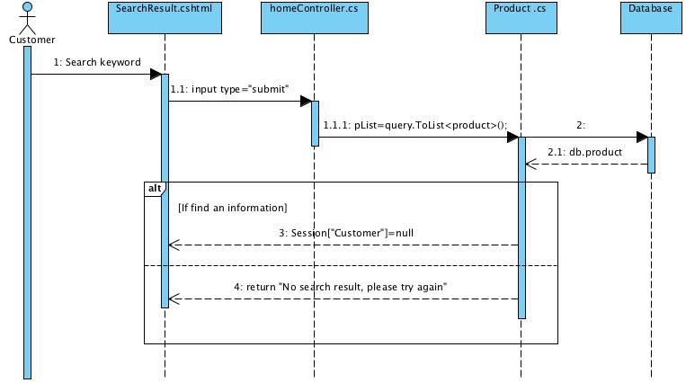

SD.2-7: Customer view Shopping Cart item(s) in the history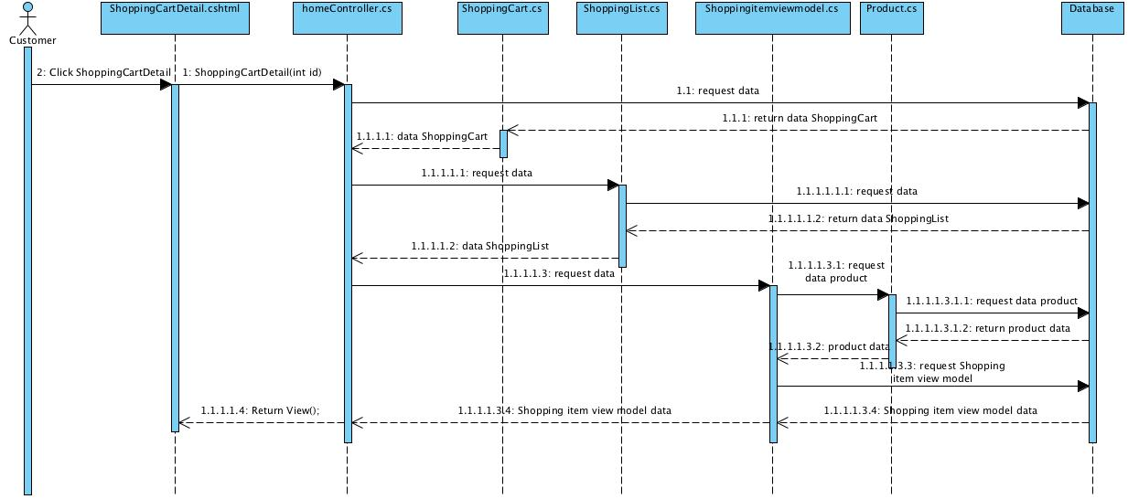

SD.2-8: Customer view currently active Shopping Cart